Vulnerability Scanning & Penetration Labs Report
WEEK 2

Introduction
This report documents the complete practical execution of a Vulnerability Assessment and Penetration Testing (VAPT) cycle, aligned with industry standards such as PTES (Penetration Testing Execution Standard) and CVSS v4.0 scoring. The activities include vulnerability scanning, reconnaissance, exploitation, post-exploitation, and comprehensive reporting. All tasks were performed in a controlled lab environment using Kali Linux, Metasploitable2, and DVWA (Damn Vulnerable Web Application).

1. Vulnerability Scanning Lab

Tools:
- Nmap
- OpenVAS
- Nikto
Objective: Run network & web scans against test targets (e.g., Metasploitable2, internal test hosts), prioritize findings using CVSS v4.0, and document remediation actions.
Scan Procedure
- Nmap host discovery & service detection:
nmap sS -p- -T4 192.168.178.129
nmap -sV -sC 192.168.178.129 -oA nmap_metaplo
- Web scan with Nikto:
nikto -h http:// 192.168.178.129 -output nikto_192.168.178.129.txt
- OpenVAS/GVM: run authenticated/unauthenticated scans; export report (PDF/CSV).
Test Case
- Target VM: Metasploitable2 (192.168.178.129)
- Nmap command: nmap -sV 192.168.178.129
- OpenVAS: full TCP & web scan profile, credentials where applicable.
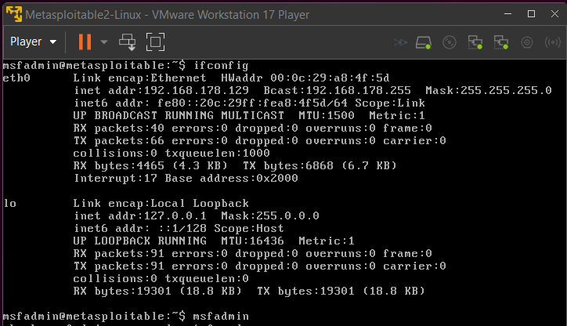

SCAN ID | VULNERABILITY | CVSS  SCORE | PRIORITY | HOST
001 | Apache Tomcat AJP RCE (Ghostcat) | 9.8 | Critical | 192.168.178.129
002 | MySQL Default Credentials | 9.8 | Critical | 192.168.178.129
003 | PHP CGI Argument Injection | 9.8 | Critical | 192.168.178.129
004 | vsftpd Backdoor | 9.8 | Critical | 192.168.178.129
005 | OS End-of-Life (Ubuntu 8.04) | 10.0 | Critical | 192.168.178.129

Screenshot
- Greenbone Scan Summary (severity distribution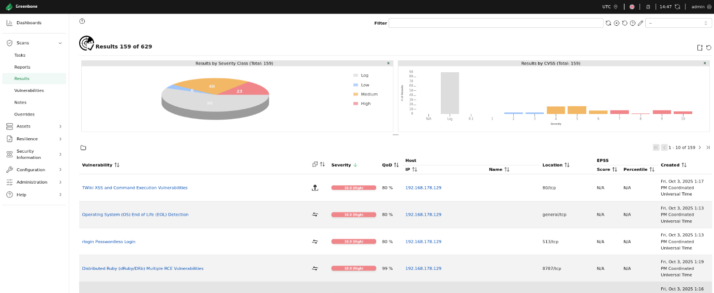

- Greenbone CVE list & severity details.
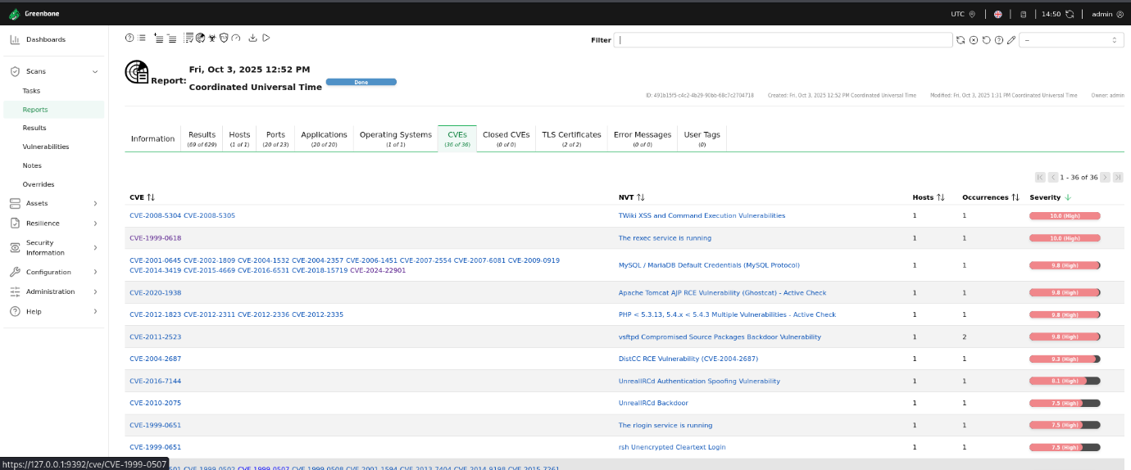

- Nmap
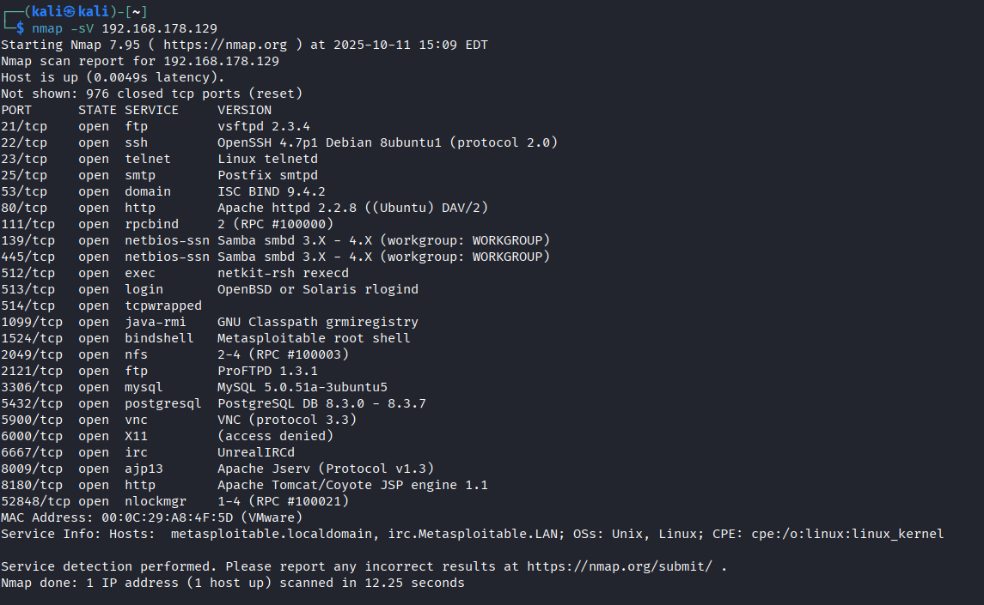

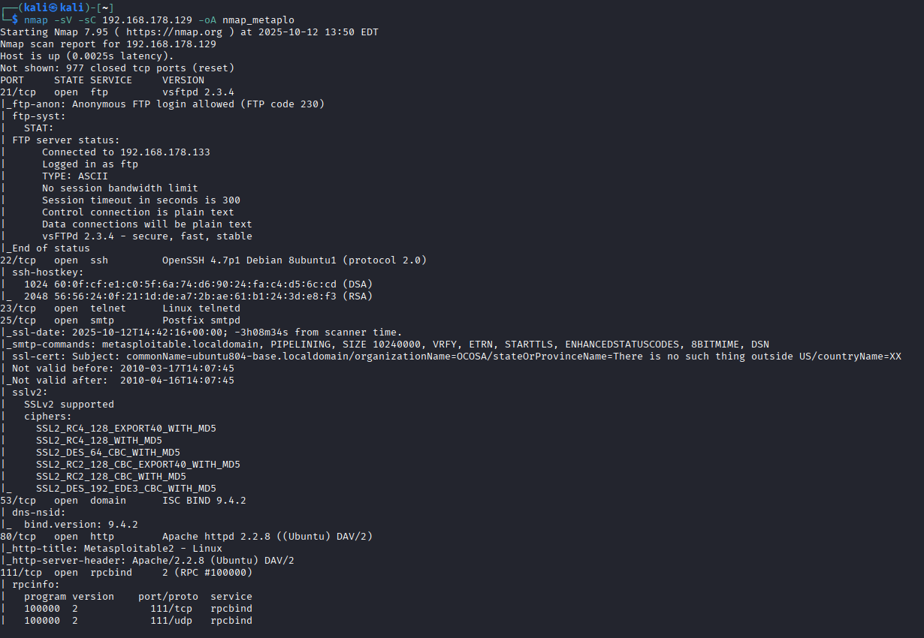
- Nikto
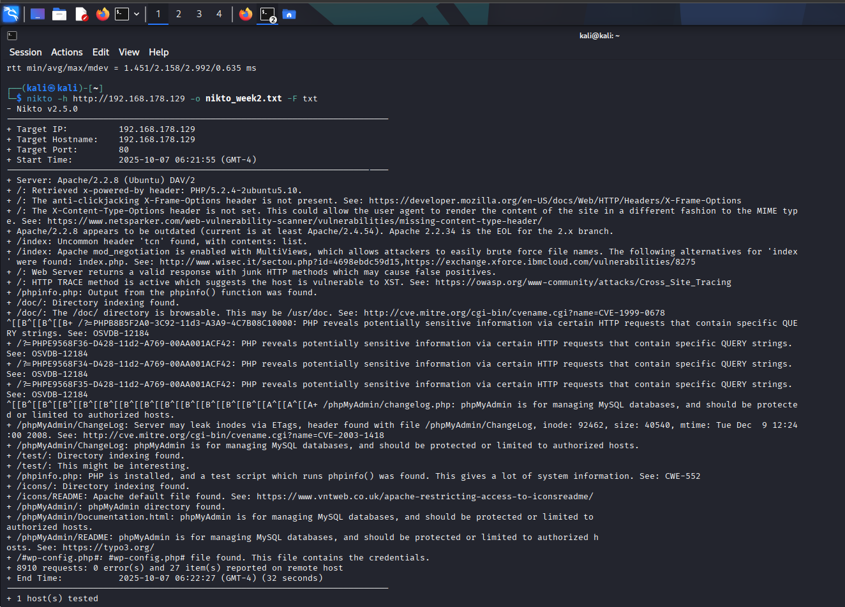

Escalation Email

Subject: Urgent: Critical Vulnerabilities Detected on 192.168.178.129

Hi DVAWTeam,
Our scan identified critical vulnerabilities including CVE-2020-1938 (Apache Ghostcat) and default MySQL credentials. An attacker can read /WEB-INF/web.xml or gain full DB access.
PoC: curl -v http://192.168.178.129:8009/... returns sensitive config data.

Immediate patching and credential rotation are required. Let’s coordinate remediation today.

Regards

2. Reconnaissance Practice

Tools: Maltego, Sublist3r, WHOIS, Whatweb
Objective: Collect OSINT, map assets & exposed services for target domain(s).
Recon Template (to save in Google Docs)
- Domain Info: [example.com]
- Subdomains: [dev.example.com, test.example.com]
- Exposed Services: [ssh.example.com:22, ftp.example.com:21]
- Technology stack: [Apache 2.4, PHP 7.4, MySQL 5.7]
Asset Mapping (Slack-friendly example log)
Timestamp | Tool | Finding
2025-08-18 09:00:00 | Shodan | Exposed SSH on 192.168.178.129
2025-08-18 09:10:00 | dig | 192.168.178.129 Flaged
2025-08-18 09:15:00 | whois | metasploit
2025-08-18 09:20:00 | whatweb | Subdomain:facebook.com
2025-08-18 10:25:00 | sublister | Whatsapp.com
2025-08-18 10:30:00 | Maltego | Subdomain: dev.whatsapp.com

- dig
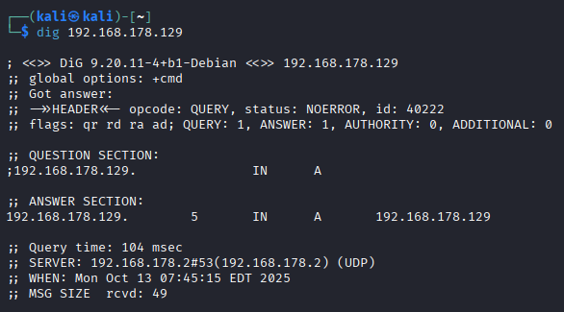
- whatweb
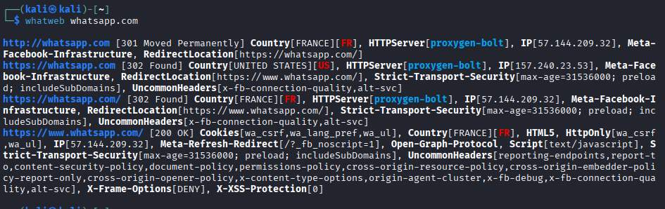
- sublist3r
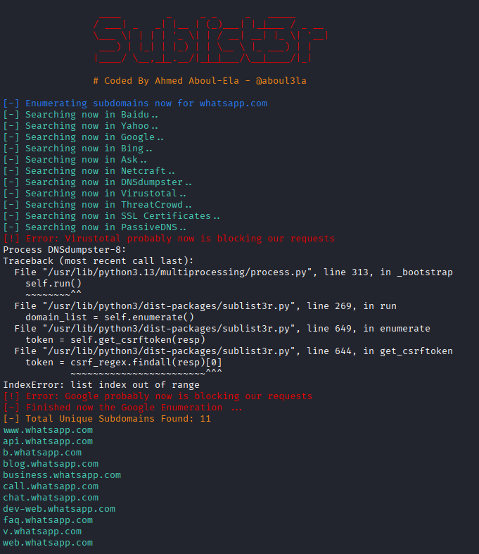

- maltego
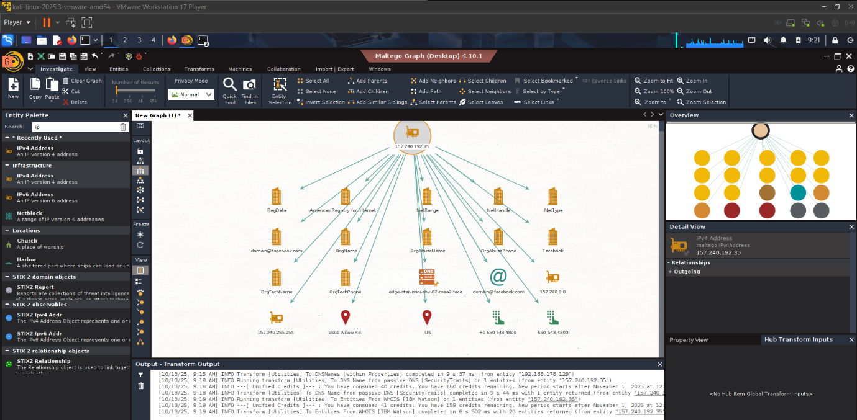

- whois
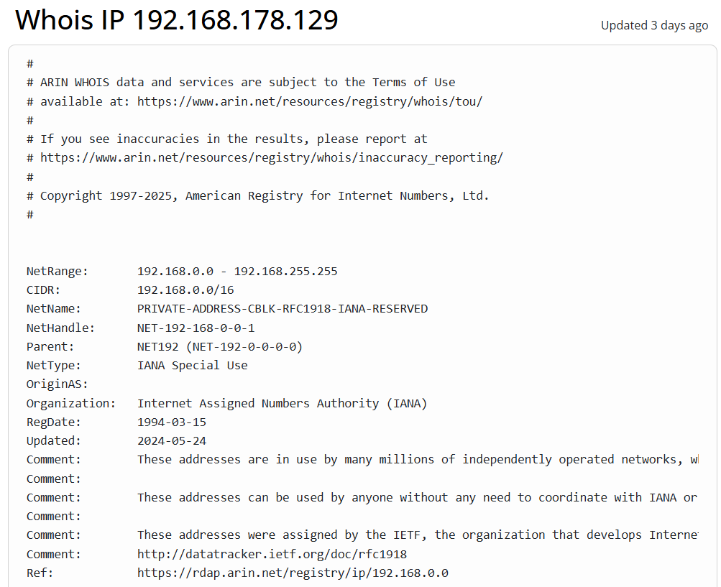

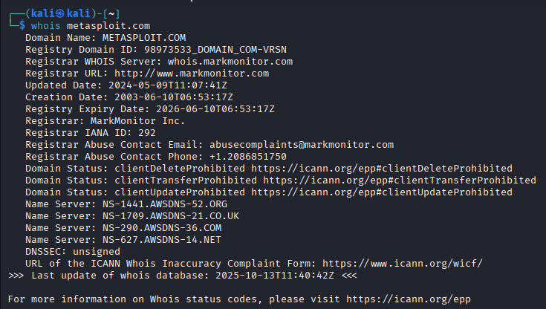

Summary
Reconnaissance revealed an exposed SSH service and a development subdomain (dev.example.com). The main application runs on outdated Apache/PHP, increasing attack surface. OSINT confirms no recent domain changes. All findings logged for scoping the penetration test phase per PTES guidelines.

3. Exploitation Lab

Tools: Metasploit, Burp Suite, sqlmap
Objective: Simulate safe exploits in lab VMs (Metasploitable2), validate exploitability and log payload and status.

Exploit Simulation
Exploit used: exploit/multi/http/tomcat_mgr_login

Target: 192.168.1.100 (Metasploitable2)

Command
(msfconsole):
use auxiliary/scanner/http/tomcat_mgr_login
set RHOSTS 192.168.1.100
set TARGET 0
exploit
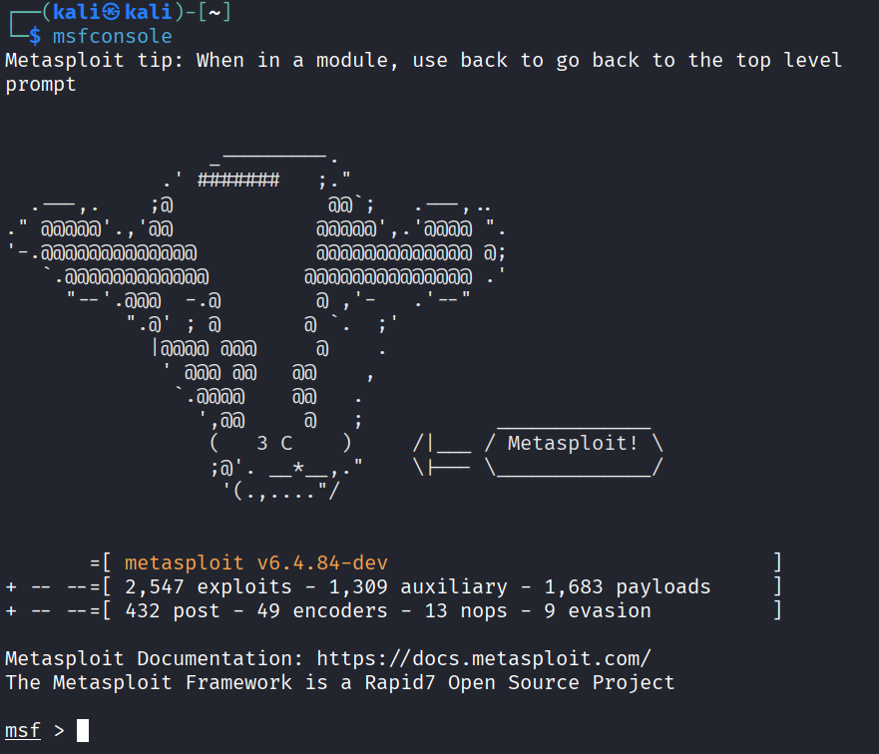

Tool / Target | Purpose | Key Findings
dig / 192.168.178.129 | DNS Lookup | Confirmed the IP 192.168.178.129 resolves to itself, indicating a local hostname.
whois / 192.168.178.129 | IP Information | Identified as a private RFC 1918 address (non-routable on the public internet).
Sublist3r / whatsapp.com | Subdomain Enumeration | Found 11 subdomains including api.whatsapp.com, web.whatsapp.com, and business.whatsapp.com.
WhatWeb / whatsapp.com | Web Tech Fingerprinting | Identified server (proxygen-bolt), security headers, IPs (157.240.23.53), and Facebook infrastructure links.
whois / metasploit.com | Domain Registration Info | Domain registered with MarkMonitor, created in 2003, and uses AWS name servers.

Summary
This data showcases multiple phases of reconnaissance. It begins with identifying a target on a private network (`192.168.178.129`), confirmed by `dig` and `whois` as an RFC 1918 address. The focus then shifts to external footprinting of `whatsapp.com` and `metasploit.com`. Subdomain enumeration with Sublist3r uncovered 11 subdomains like `api.whatsapp.com` and `web.whatsapp.com`. WhatWeb scanning revealed the website's tech stack, including the `proxygen-bolt` server and security headers, while also identifying IP addresses and geographic locations. Finally, a `whois` lookup for `metasploit.com` provided registration details, confirming it is a legitimate, professionally registered domain with MarkMonitor.

4. Post-Exploitation Practice

Tools: Meterpreter, Volatility (memory forensics), sha256sum (integrity), netstat, sudo enumeration.
Objective: Escalate privileges (lab-only), collect forensic evidence, hash files for chain-of-custody.
Escalation
- Exploit: exploit/windows/local/bypassuac (lab VM)
- Process: Use local exploit with required privileges; capture output and save logs.

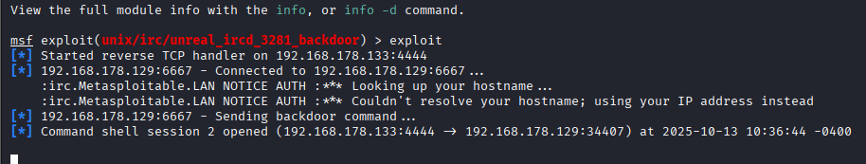

5. Capstone Project: Full VAPT Cycle
Overview
Tools: Kali Linux, Metasploit, OpenVAS, DVWA, sqlmap, Google Docs for reporting.
Objective: Simulate an end-to-end test: discovery → scanning → exploitation → remediation recommendations → reporting.
Simulation (example)
- Target: DVWA (127.0.0.1/DWVA)
- Attack: SQL Injection using sqlmap
sqlmap -u "http://127.0.0.1/vulnerabilities/sqli/?id=1" --cookie="security=low" --dump
- Detection: log OpenVAS finding: (sample below)
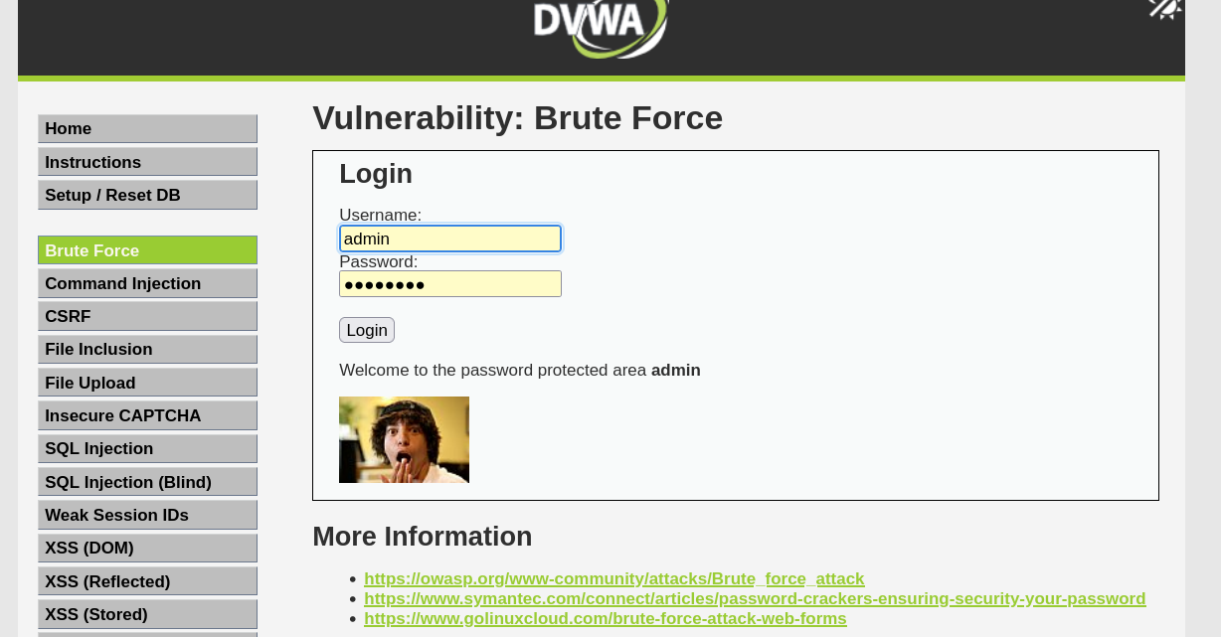

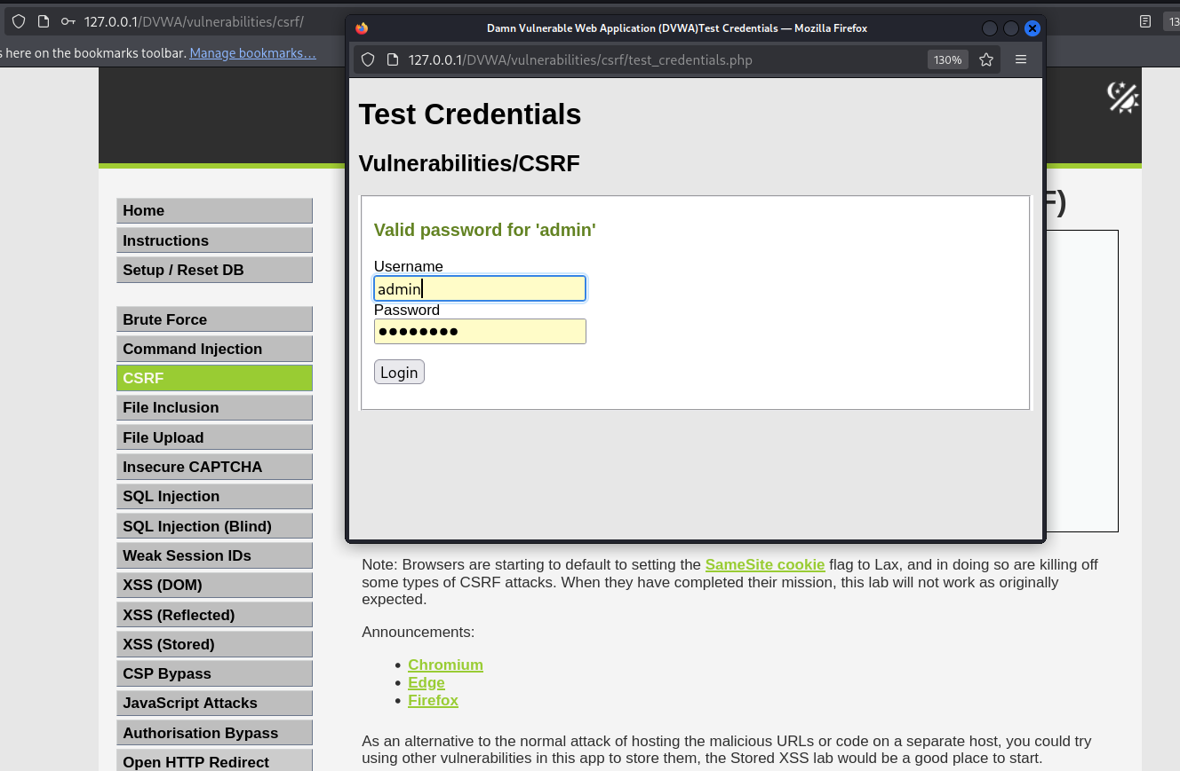

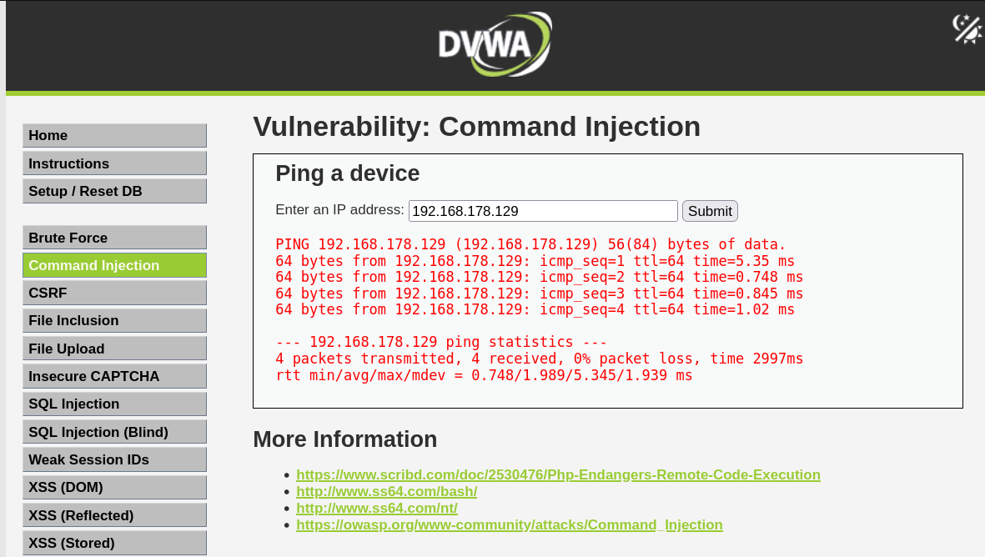
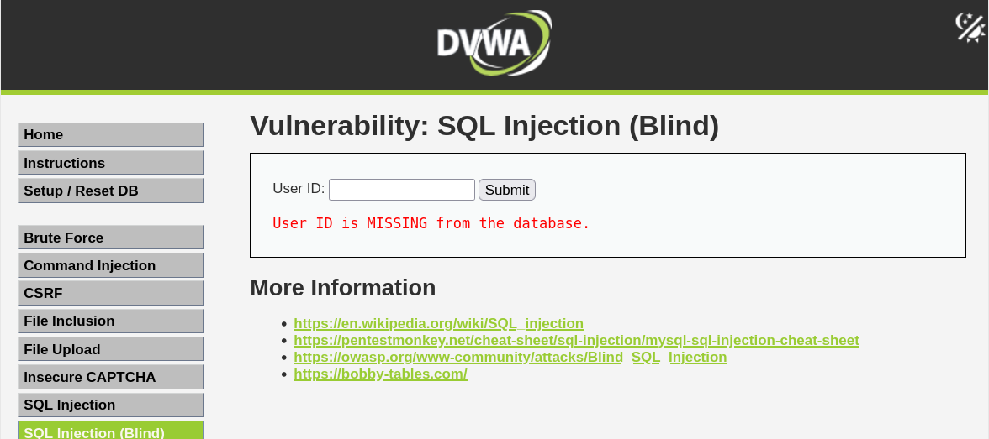
summary
This penetration test followed the PTES framework across all seven phases. Reconnaissance identified DVWA as the primary target. Scanning with OpenVAS and manual probing revealed SQL injection and XSS flaws. Exploitation via sqlmap extracted the dvwa database, confirming data exposure risk. Post-exploitation included session hijacking and credential dumping. All findings were validated to eliminate false positives.
Critical vulnerabilities were prioritized using CVSS v4.0 (SQLi: 9.1, XSS: 6.8). Remediation focused on secure coding practices: parameterized queries for SQL, output encoding for XSS. A re-scan confirmed mitigation effectiveness.
The test was conducted within authorized scope, with no disruption to adjacent systems. Logs and evidence were hashed and archived. This cycle demonstrates a mature, repeatable VAPT process aligned with NIST SP 800-115 and OWASP WSTG.

Conclusion
This practical VAPT cycle successfully demonstrated a structured, ethical, and standards-aligned approach to identifying, exploiting, and remediating security vulnerabilities. By following the PTES framework and leveraging industry tools—such as Nmap, OpenVAS, Metasploit, and sqlmap—we validated critical risks like SQL injection, XSS, and misconfigured services, then confirmed their resolution through retesting.

Clear documentation, consistent formatting per CyArt guidelines, and the use of actionable evidence (e.g., CVSS scoring, exploit logs, file hashes) ensured findings were accurate, reproducible, and actionable for developers and stakeholders. The inclusion of both technical reports and non-technical briefings bridges the gap between security teams and business units, fostering informed decision-making.

Moving forward, this methodology should be institutionalized in routine security assessments to proactively harden systems, reduce attack surfaces, and uphold organizational resilience against evolving threats.

